Solar Science: Exploring Sunspots, Seasons, Eclipses and More
An Award-winning Publication by Dennis Schatz & Andrew Fraknoi

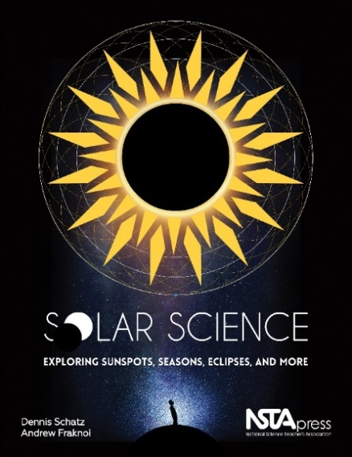
Designed for teachers in grades 5–8, curriculum specialists, and informal educators, Solar Science: Exploring Sunspots, Seasons, Eclipses, and More includes 45 activity-based lessons related to the Sun, plus all the background information and classroom resources you need to lead them successfully. The topics covered include the Sun's motions, space weather caused by the Sun, the measurement of time and seasons in our daily lives, and the causes of solar and lunar eclipses. The book’s core is a series of student-centered learning experiences that put the students in the position of being scientists -- by having them ask questions, explore phenomena, and draw, discuss, & refine conclusions. Schatz and Fraknoi provide classroom-tested activities throughout the book that support the three-dimensional learning encouraged by the Next Generation Science Standards and connect to the Common Core State Standards. https://my.nsta.org/resource/102100/solar-science-exploring-sunspots-seasons-eclipses-and-more
___________________________________________________________________________

When the Sun Goes Dark
A Colorful Introduction to Solar and Lunar Eclipses for Kids
by Andrew Fraknoi & Dennis Schatz (NSTA Kids)
Designated an Outstanding Science Trade Book for 2018

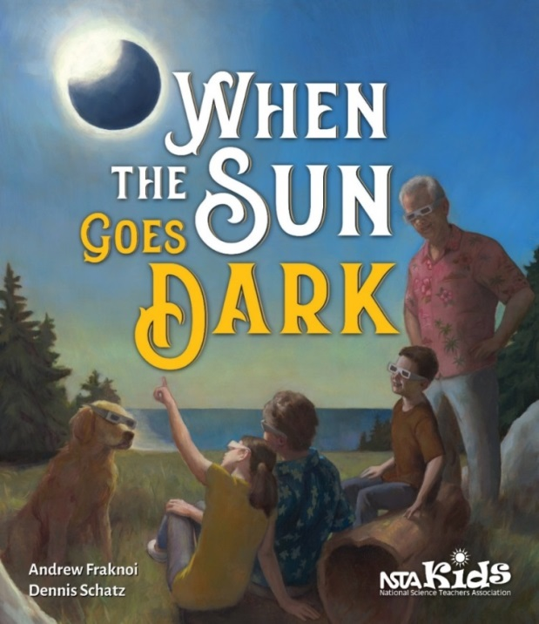
In this richly illustrated, 36-page book, 12-year-old Diana and her younger brother, Sammy, want to know why their grandparents travel thousands of miles to see total eclipses of the Sun. Readers follow the kids’ questions and learn the science behind solar and lunar eclipses, what makes these sky events so special, and how to observe eclipses safely. When the Sun Goes Dark provides a great introduction for families and serves as an excellent resource for teachers and librarians as they prepare for helping young people understand eclipses of the Moon and the Sun. The authors are experienced astronomers and educators, who have written over 25 children’s books between them. See reviews & order at: https://my.nsta.org/resource/108257

You can order the books at the National Science Teachers Association Press website:
http://www.nsta.org/store or at on-line booksellers, such as Amazon.
Quantity discounts are available.

